# Employee Development in 2012

One of the actions stemming from the 2011 Employee Satisfaction survey and approved by Jeff Gordon’s executive team is to ensure that all employees have a Development plan for 2012.

HR representatives are meeting with leaders throughout the organization to explain the process. Please contact John Menken, 813.637.5466, [john.menken@syniverse.com](mailto:john.menken@syniverse.com) with questions on employee development and creating a development objective for yourself or direct reports if appropriate.

The objective is to have development plans in the Success Factors system by June 31, 2012.

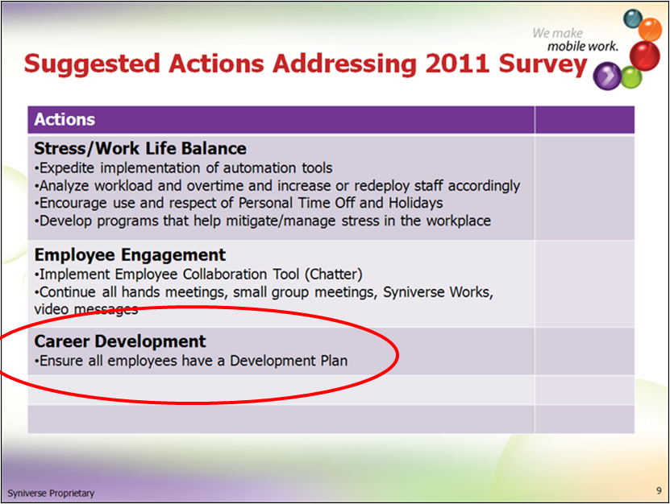

# Resources:

**SKR:**

Manager/Employee Worksheets and Sample Development plans

<http://skrcollab.syniverse.com/gm/folder-1.11.115876>

**Geo Learning Resources:**

Holding a Development Discussion

<https://gm1.geolearning.com/geonext/syniverse/coursesummary.CourseCatalog.geo?id=22506129390>

The Necessity for Career Development

<https://gm1.geolearning.com/geonext/syniverse/coursesummary.CourseCatalog.geo?id=22506129391>

Employee Development in Success Factors

<https://gm1.geolearning.com/geonext/syniverse/coursesummary.CourseCatalog.geo?id=22506129389>